We Know They Are Killing Children — All of Us Know
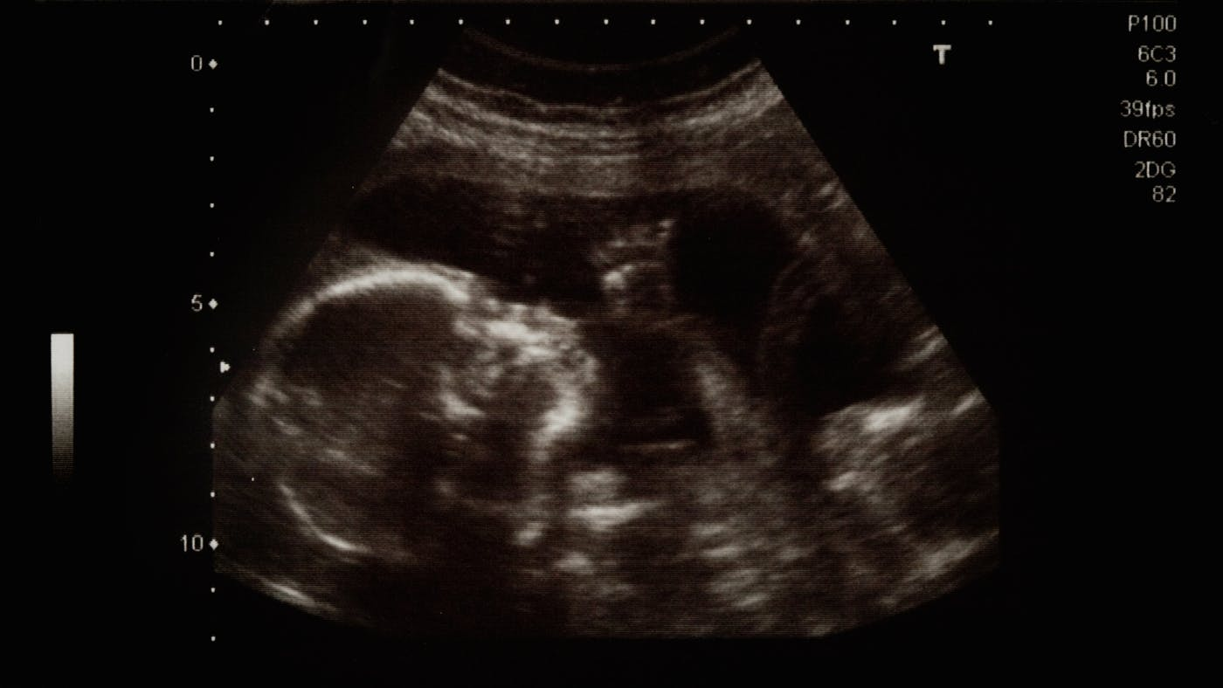
Article by
John Piper
Founder & Teacher, desiringGod.org
One biblical principle of justice is that the more knowledge we have that our action is wrong, the more guilty we are, and the more deserving of punishment (Luke 12:47–48). The point of this article is that, when it comes to abortion, we know what we are doing — all America knows. We are killing children. Pro-choice and pro-life people both know this.
But before I show that, let’s clarify what the Supreme Court did 45 years ago. In Roe v. Wade the Supreme Court in effect made abortion on demand untouchable by law. The way this was done was with two steps.
One step was to say, laws may not prevent abortion, even during the full nine months, if the abortion is “to preserve the life or health of the mother.” The other step was to define “health” as “all factors — physical, emotional, psychological, familial and the woman’s age — relevant to the well-being of the patient.”
For 40 years this has meant that any perceived stress is a legal ground for eliminating the child. We have killed over 50 million babies. And what increases our guilt as a nation is that we know what we are doing. Here’s the evidence that we know we are killing children.

1. Anecdotally, abortionists will admit they are killing children.
Many simply say it is the lesser of two evils. I took an abortionist out to lunch once, prepared to give him ten reasons why the unborn are human beings. He stopped me, and said, “I know that. We are killing children.” I was stunned. He said, “It’s simply a matter of justice for women. It would be a greater evil to deny women the equal right of reproductive freedom.”
Which means women should be no more encumbered by the consequences of an unplanned pregnancy than men. That equal freedom from the burden of bearing unwanted children is the basis for abortion that President Obama referred to again and again in public when he talked about equal rights for women. We know what that means. We are killing children.

2. States treat the killing of the unborn as a homicide.
We know what we are doing because 38 states (including Minnesota) treat the killing of an unborn child as a form of homicide. They have what are called “fetal homicide laws.”
“When the unborn are wanted, they are treated as children and patients. When they are unwanted, they are not children.”

Tweet
Share on Facebook
It is illegal to take the life of the unborn if the mother wants the baby, but it is legal to take the life of the unborn if she doesn’t. In the first case the law treats the fetus as a human with rights; in the second case the law treats the fetus as non-human with no rights.
Humanness is thus defined by the desire of the strong. Might makes right. We reject this right to define personhood in the case of Nazi anti-Semitism, Confederate race-based slavery, and Soviet Gulags. When we define the humanness of the unborn by the will of the powerful we know what we are doing.

3. Fetal surgery treats the unborn as children and patients.
High risk pregnancy specialist, Dr. Steve Calvin, in a letter some years ago to the Arizona Daily Star, wrote, “There is inescapable schizophrenia in aborting a perfectly normal 22 week fetus while at the same hospital, performing intrauterine surgery on its cousin.” When the unborn are wanted, they are treated as children and patients. When they are not wanted, they are not children. We know what we are doing.

4. Being small does not disqualify personhood.
The five-foot-eight frame of a teenage son guarantees him no more right to life than the 23-inch frame of his little sister in her mother’s arms. Size is, we know, morally irrelevant. One inch, 23 inches, 68 inches — does not matter. It is morally irrelevant in deciding who should be protected. We know what we are doing in killing the smallest.

5. Not having a developed reasoning power does not disqualify personhood.
A one-month-old infant, nursing at his mother’s breast, does not have reasoning powers. But only a few dare argue that infanticide is therefore acceptable. Most know better. Outside and inside the womb the infant cannot yet reason, but, in spite of that, is a human person. We know what we are doing.

6. Being in the womb does not disqualify human personhood.
Location or environment does not determine a right to life. Scott Klusendorf asks, “How does a simple journey of seven inches down the birth canal suddenly transform the essential nature of the fetus from non-person to person?” We know what we are doing.

7. Being dependent on mommy does not disqualify personhood.
We consider persons on respirators or dialysis to be human beings. The unborn cannot be disqualified from human personhood because they are dependent on their mother for food and oxygen. In fact, we operate on the exact opposite principle: The more dependent a little one is on us, the more responsibility we feel to protect him, not the less. We know what we are doing.
(Those last four observations, points 4 through 7, were summed up by Scott Klusendorf under the acronym SLED: Size, Level of development, Environment, Degree of dependence — none is morally relevant for the definition of human life.)

8. The genetic makeup of humans is unique.
The genetic makeup of a human is different from all other creatures from the moment of conception. The human code is complete and unique from the start. Once that was not known. Now we know.

9. All the organs are present at eight weeks of gestation.
At eight weeks of gestation all the organs are present. The brain is functioning, the heart pumping, the liver making blood cells, the kidney cleaning the fluids, the finger has a print. Yet almost all abortions happen later than this date. We know what we are doing.

10. We have seen the photographs.
The marvel of ultrasound has given a stunning window into the womb that shows the unborn, for example, at 8 weeks sucking his thumb, recoiling from pricking, responding to sound. Watch this four-minute video of the developing unborn child. We know that they are children.

11. When two rights conflict, the higher value should be protected.
“Staying alive is more precious and more basic than not being pregnant.”

Tweet
Share on Facebook
We know the principle of justice that when two legitimate rights conflict, the right that protects the higher value should prevail. We deny the right to drive at 100 miles per hour because the value of life is greater than the value of being on time or getting thrills. The right of the unborn not to be killed and the right of a woman not to be pregnant may be at odds. But they are not equal rights. Staying alive is more precious and more basic than not being pregnant. We know what we are doing when we kill a child.

For Christians who believe the Bible, we could add at least ten more reasons why we know what is happening in abortion, and why it is wrong. But the aim here is threefold.
1. We aim to make clear that we will not be able to defend ourselves with the claim of ignorance. We knew. All of us. It is astonishing how relevant Proverbs 24:11–12 is to our present situation of abortion:
Rescue those who are being taken away to death; hold back those who are stumbling to the slaughter. If you say, “Behold, we did not know this,” does not he who weighs the heart perceive it? Does not he who keeps watch over your soul know it, and will he not repay man according to his work?
2. We aim to solidify our conviction to resist this horrific evil.
3. We aim to intensify our prayer and our preaching toward gospel-based soul-renovation in our land, because sinful hardness of heart, not innocent ignorance, is at the root of this carnage.

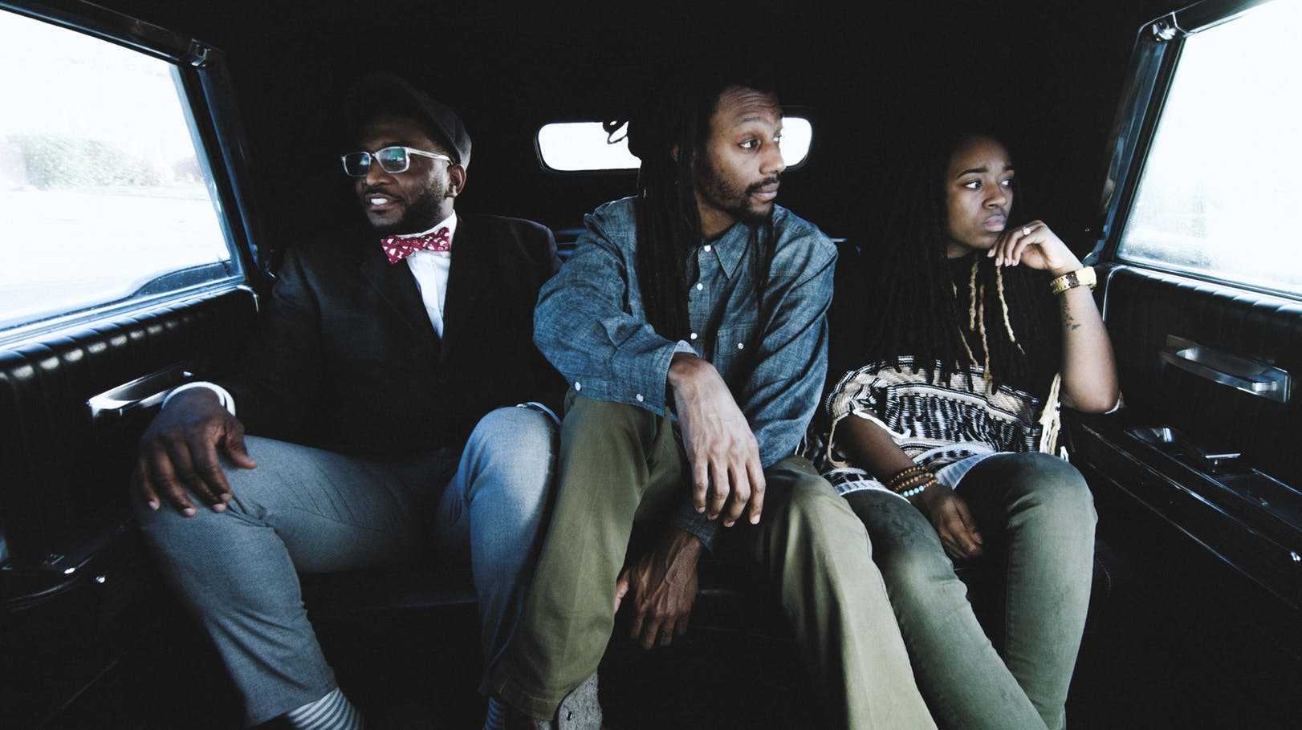

73-17
Jan 22, 2017
Sho Baraka + 2
14.2K

John Piper (@JohnPiper) is founder and teacher of desiringGod.org and chancellor of Bethlehem College & Seminary. For 33 years, he served as pastor of Bethlehem Baptist Church, Minneapolis, Minnesota. He is author of more than 50 books, including Reading the Bible Supernaturally.

